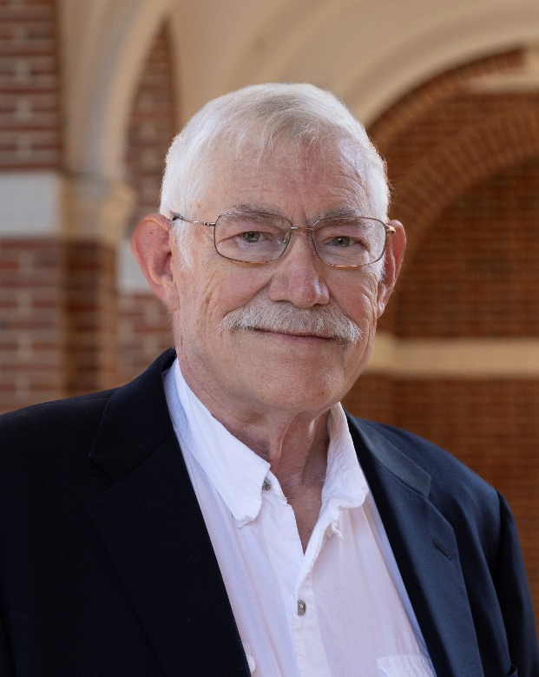
Speaker Biography –
Dr. Russell H. Taylor has over 35 years’ experience in medical robotics and over 50 in robotics research. He received his Ph.D. in Computer Science from Stanford in 1976. After spending 1976 to 1995 as a Research Staff Member and research manager at IBM Research, he moved to Johns Hopkins University, where he is the John C. Malone Professor of Computer Science with joint appointments in Mechanical Engineering, Radiology, Surgery and Otolaryngology – Head and Neck Surgery. His research for the past 35 years has focused on medical robotics and computer-integrated interventional medicine. He is the author of over 650 peer-reviewed journal and conference papers and holds 100 patents. He is a Member of the US National Academy of Engineering and has received many other significant awards and honors.

Human-Machine Partnerships in Computer-Integrated Interventional Medicine: Yesterday, Today, and Tomorrow
Russell H. Taylor
The Johns Hopkins University
This talk will discuss insights gathered over 35 years of research on medical robotics and computer-integrated interventional medicine (CIIM), both at IBM and at Johns Hopkins University. The goal of this research has been the creation of a three-way partnership between physicians, technology, and information to improve treatment processes. CIIM systems combine innovative algorithms, robotic devices, imaging systems, sensors, and human-machine interfaces to work cooperatively with surgeons in the planning and execution of surgery and other interventional procedures. For individual patients, CIIM systems can enable less invasive, safer, and more cost-effective treatments. Since these systems have the ability to act as “flight data recorders” in the operating room, they can enable the use of statistical methods to improve treatment processes for future patients and to promote physician training. We will illustrate these themes with examples from our past and current work, with special attention to the human-machine partnership aspects, and will offer some thoughts about future research opportunities and system evolution.
Poster Summary:
From early robotics to today’s intelligent surgical systems, Dr. Russell H. Taylor traces the evolution of human-machine collaboration in medicine and what’s next for safer, smarter, and more personalized care.

